2013 HANDBOOK
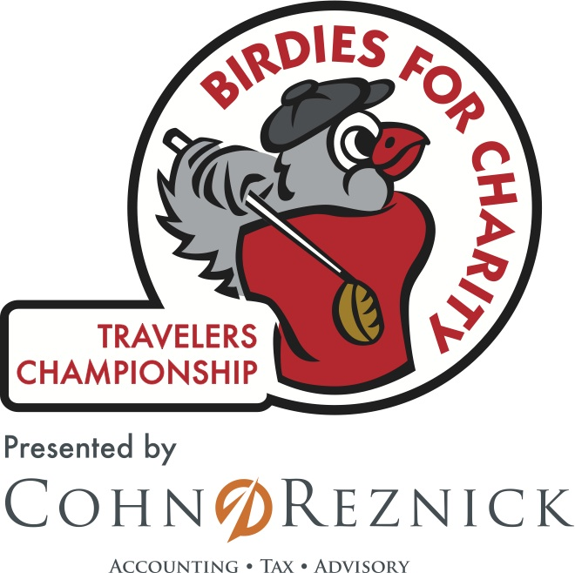

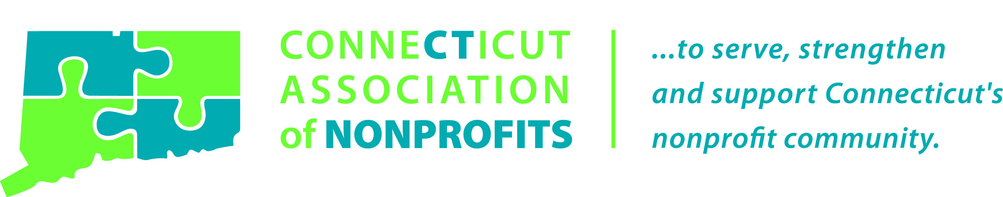

Birdies for Charity 5 Step Process

- Register for the Birdies for Charity Program
- Generate Pledges
  - Online Donations
  - Pledge Card Donations

- Submit Pledges to CohnReznick

- Birdies for Charity Staff Sends Invoices to Donors

- Your Nonprofit Receives a Check for 100% of Generated Donations

Table of Contents

About the Travelers Championship, PGA TOUR, and Birdies for Charity Page 3

Birdies for Charity Roles and Responsibilities Page 4

Pledge Solicitation Page 5

Billing Information Page 6

Donor Incentives Page 7

Charity Incentives Page 8

Frequently Asked Questions Page 9

Top Ten Helpful Hints Page 10

Additional Program Support & Resources Page 11

Sponsors Page 12

About the Travelers Championship and the

PGA TOUR Tradition of Giving Back

The Travelers Championship is unlike any other professional sport entity in that it donates 100 percent of net proceeds to charity every year. Since 1952, the tournament has given more than $30 Million back to the community and in 2012, the Travelers Championship generated over $1 Million for more than 100 charities throughout New England. The tournament is committed to supporting our charitable community through Birdies for Charity and Chip In for Charity that allow every 501(c)(3) ability to partner with the Travelers Championship to raise funds and awareness for its cause.

Launched in 2004, Birdies for Charity provides every 501(c)(3) in Connecticut an opportunity to raise funds by collecting pledges based on the number of birdies made by PGA TOUR professionals during the week. At the conclusion of the tournament, the Travelers Championship calculates the number of birdies made by the pledge amounts and distributes invoices to each donor. For example, if an individual makes a 1-cent pledge and there are 1,800 birdies made, that individual would make a donation of $18 to the charity of their choice. At the conclusion of the pledge collection season, the Travelers Championship returns 100% of collected pledges to the participating charities.

About Birdies for Charity

How does Birdies for Charity work?

1) A birdie is a score of one stroke better than par for any golf hole. Par is the normal expected score for golf
professional on any given hole. PGA TOUR professionals are anticipated to make an average 1,500-2,000
birdies, Wednesday – Sunday of the Travelers Championship.

2) Participating charities solicit pledges from their donors based on the number of birdies that will be made.
Pledges can be as low as one penny! If a donor pledges just 1-cent and 1,500 birdies are made, the donor
will contribute $15 to the charity of their choice.

3) At the conclusion of the tournament, the Travelers Championship and the Birdies for Charity presenting
sponsor, CohnReznick will distribute invoices to all donors.

4) The Travelers Championship and CohnReznick will manage the pledge collection. Following multiple
rounds of billing, the Travelers Championship will provide each charity with a check for 100% of pledges
collected.

5) 100% of funds will be returned directly to your organization!

Birdies for Charity Roles and Responsibilities
Charity Responsibilities
All participating charities will have the sole responsibility of soliciting pledges on behalf of their organization and submitting those pledges either via the Travelers Championship Birdies for Charity website or to
CohnReznick for processing, billing and collection.

Each participating charity must also designate one representative to be the Travelers Championship's primary contact for the Birdies for Charity Program, the Administrator.

Birdies for Charity - Administrator
- Only ONE Administrator per participating organization, chosen by the organization.
- Administrators are required to attest to the validity of their charity’s fundraising efforts.
- Administrators are asked to encourage their friends, families, co-workers and/or board of directors to support the collection process of all funds.
- Following the tournament, Administrators are responsible for reviewing all submitted pledges and flat rate donations (via summary sheet provided by tournament). This summary will be distributed within seven days of the tournament’s conclusion. The information in this report will be assumed correct, if no discrepancies are reported PRIOR to July 8, 2013.
- If at any time an Administrator changes/leaves your organization, a new registration form MUST be signed by the new Administrator in order for the organization to receive information and funds.

Travelers Championship Responsibilities

The Birdies for Charity Program will be administered by the staff of the Travelers Championship and
CohnReznick. All funds collected will be processed through the Birdies for Charity account of the
Travelers Championship.

Administrative functions include, but are not limited to the following:
- Registering all participating charities
- Developing and distributing all program materials and pledge website information to participating charities
- Collecting prizes
- Administering all Birdies for Charity webinars, training sessions and conference calls
- Processing all pledge forms received from participating charities
- Tracking and updating all pledge and flat rate donations
- Supporting the participating charity and Administrator’s fundraising strategies
- Hosting (5) participating charities on-site at the 2013 Travelers Championship (see page 9)
- Billing and collecting of all pledges and flat rate donations
- Providing summary reports of collection status to each participating Administrator
- Hosting the annual Charity Check Presentation in the Fall of 2013

Pledge Solicitation
- Paper Pledge Forms

Upon registering, the Travelers Championship will provide each charity with pledge forms to get started. Remember, photocopied pledge forms will be accepted at all times and pledge forms will be available for download from TravelersChampionship.com.

- Online Pledges

Once you register to participate in the Birdies for Charity Program, each organization will be provided with their own online pledge website. This pledge website will provide the following features:

- Each organization will be given a unique link to their own pledge website.

- All Administrators will be provided with a username and password to log onto their Birdies for Charity website. They will have the ability to track and enter their own pledges/ flat rate donations and to access comprehensive progress reports during the pledge and payment seasons.

- Each organization’s individual pledge website will allow the donor to not only select the organization as the charity of choice; it also will provide the donor with the opportunity to click on the organization’s website, if they are interested in more information.

How simple is pledging online?

- Direct donors to your organization’s Birdies for Charity website link or to TravelersChampionship.com to make a per birdie pledge or flat rate donation.

- Ask donors to complete the simple registration form on the first page and then to follow the system prompts to make a donation.

- Finally, once donors enter their contact information and donation, the program will ask them to participate in the “Guess the Birdies Sweepstakes”. This sweepstakes allows the donor to guess how many birdies will be made from Wednesday – Sunday of the
2013 Travelers Championship.

- At the conclusion of the 2013 Travelers Championship, all unpaid flat rate and per birdie donations will receive an electronic and/or paper invoice providing their payment information. Donors can simply log back onto the pledge website and make a payment via credit card or send a check made out to the “Travelers Championship” to Attn: Birdies for Charity,
CohnReznick, 180 Glastonbury Blvd, 4th Floor, Glastonbury, CT 06033 for processing.

Billing Process Information

- Following the 2013 Travelers Championship, the tournament staff will provide each Administrator with a summary of their donors and the subsequent pledges and flat rate donations collected, which must be reviewed prior to July 8, 2013.
- The Travelers Championship will issue multiple rounds of invoices, beginning on July 15, 2013 and continuing every three weeks throughout the summer.
- 1st Round (July 15th) – Electronic /paper invoices for donors without email address
- 2nd Round (week of August 12th) – Electronic / paper invoices to all unpaid donors without an email address
- 3rd Round – (week of September 9th) – Paper invoices to all remaining unpaid donors
All payments will be accepted at or above the pledge/ flat rate amount. Please note the Birdies for Charity Program will provide 100% of any additional funds collected to the participating charity.

  - However, for Birdies Bonus Bucks purposes, the tournament reserves the right to only count funds received up to $5.00 over the pledge /flat rate committed amount. This means if a donor pledged 1-cent per birdie and 1,500 birdies are made, $15.00 is the expected donation. Payments at or below $20 will be tracked and counted toward the Birdies Bonus Bucks Program and all other funds will simply be sent directly to the charity.

All individual pledges and flat donations must be sent in via pledge form or through the Birdies for Charity website before June 23, 2013 at 6:00 p.m. or they will not be accepted for processing.

Participating charities and their administrators will NOT be allowed to submit lists of donor information for processing. All per birdie pledges and flat rate donations must be submitted on the official pledge form (photocopied/printed versions are acceptable) or through the Birdies for Charity website.
Checks- Must be payable to “Travelers Championship”
All checks MUST be received with a copy of the Birdies for Charity invoice indicating the pledge or flat rate donation that the payment is intending to cover. Any checks received without an invoice will NOT be accepted and will be returned promptly to the donor.

Checks-Must be sent to: Attn: Birdies for Charity
CohnReznick
180 Glastonbury Blvd, 4th Floor
Glastonbury, CT 06033

At no time will the Birdies for Charity Program accept payments that were tracked and collected by the participating organization. All payments (both check and credit card) MUST come from the ORIGINAL DONOR. Payments from the participating charity or another individual on behalf of a donor will not be accepted without prior authorization from the Travelers Championship staff.

Donor Incentives
Guess the Birdies Sweepstakes

For the third year, we are pleased to offer the Guess the Birdies Sweepstakes, proudly sponsored by The Connecticut Association of Nonprofits. This sweepstakes provides each donor the opportunity to have one guess at the number of birdies made (Wed.-Sun.) of tournament week. The person who correctly guesses the exact number of birdies will win the Grand Prize of one 24-Month Lease on a 2013 Ford Fusion SE Hybrid. In addition, due to the continued support from the Connecticut Association of Nonprofits, your nonprofit of choice will receive an additional $500 donation, a year membership and four training sessions with their organization.

Other prizes, depending upon eligible entries in the event of a tie, include:
  - A World Golf Hall of Fame Vacation package which include:
    - Two nights at the Renaissance Hotel in St. Augustine, Florida
    - One round of golf for two at The Slammer & Squire World Golf Village
    - One golf lesson for two at the PGA TOUR Academy
    - Admission for two to the World Golf Hall of Fame and IMAX Theatre
    - $600 Travel Voucher
  - Four rounds of golf at TPC River Highlands
  - $1,000 Cash Gift Card

We encourage you to take advantage of these incentives while promoting Birdies for Charity to your donors.

GUESS THE BIRDIES SWEEPSTAKES RULES
- No pledge, purchase or donation is necessary to enter the Guess the Birdies Sweepstakes. The odds of winning depend upon the number of entries received. Prizes are not transferable. There is no substitution, transfer or cash equivalent for prizes, except that Sponsor may, at its sole discretion, substitute prize of comparable value or cash.
- To request an entry form for the sweepstakes, please submit a request by mail to: Travelers Championship, 90 State House Square, 8th Floor, Hartford, CT 06103.
- All entries must be on an official pledge form, copied facsimile or be submitted through the Birdies for Charity donation website.
- The guess may be any number.
- One guess will be permitted per person and the tournament will track only the first pledge received with a proposed guess.
- Guesses will be accepted from Monday, January 28, 2013 through 6:00 pm on Tuesday, June 18, 2013.
- If the Grand Prize winner has not designated a charity with their submitted guess, the Travelers Championship will select a random charity from one of the 2013 Birdies for Charity participating organizations to receive the charitable donation Grand Prize.
- Participants must be legal residents of the United States and be 21 years of age or older as of Monday, June 17, 2013.
- In the case of a tie, the Grand Prize winner will be chosen randomly by the Travelers Championship staff from those who correctly guessed the exact number of birdies made. The other designated prizes will be randomly chosen by the Travelers Championship staff from among those who correctly guessed the number of birdies. The prizes remaining will then be given to the person who guesses closest (without going over the total) to the actual number made during the 2013 Travelers Championship, respectively.
- If no one guesses the exact number of birdies made, then the Grand Prize winner will be the person whose guess is the closest (without going over the total) to the actual number made during the 2013 Travelers Championship.
- The Grand Prize winner is responsible for insurance of the vehicle throughout the term of the lease. Winner must provide proof of insurance upon delivery. The winner will also be responsible for excess mileage greater than 15,000 miles a year for 2 years (30,000 miles total) at a cost of 0.20 cents a mile plus any applicable tax and will assume damage responsibility. Winner can purchase extra miles up front for 15 cents a mile plus tax. Winner must further adhere to all stipulations in accordance with Ford Motor Credit Company “FMCC” standard lease requirements, and shall be responsible for routine maintenance and excess wear and tear charges as well as all other liabilities at lease end as specified in the lease agreement. Grand Prize Winner must be a licensed driver. All other said terms of said lease apply. The copy of the lease will be provided to the winner.
- The Grand Prize winner will be notified following the tournament, in the summer of 2013.
- There is one prize for each place level. The Grand Prize and Prizes for 1st, 2nd and 3rd will be determined by random draw from those eligible entries in case of a tie.
- A complete set of rules is available from the Travelers Championship, upon request.

Charity Incentives
Birdies Bonus Bucks

CohnReznick is the proud sponsor of the Birdies for Charity Bonus Bucks Program. CohnReznick has generously donated $50,000 to be distributed among participating nonprofits in the following ways!

Top 10 Pledge-Collecting Organizations of the Birdies for Charity Program
- Eligibility will be determined based on pledge and flat rate dollars collected by September 30, 2013.
- Charities must raise at least the amount of the Bonus Bucks to be eligible.
- For example, to earn the 1st Place prize that charity must raise at least $5,000 in collected pledges.
1st Place: $5,000
2nd Place: $2,500 3rd Place: $2,500 4th Place: $1,000
5th Place: $1,000 6th Place: $1,000 7th Place: $500
8th Place: $500 9th Place: $500 10th Place: $500

Birdies for Charity $750 & Up Club
- Nonprofits raising $750 or more but do not make the “Top Ten Pledge-Collecting Organizations” will be put into a drawing for an additional $500.
- Twenty programs will benefit from this program.
- Eligibility will be determined based on pledge and flat rate dollars collected by September 30, 2013.

Birdies for Charity Cash Back Program – Receive 112% of Your Collected Pledges!
- For 2013, each nonprofit will receive a minimum of 12% back of the total funds they collected through the 2012 Birdies for Charity program in addition to what they raise for 2013.
- Nonprofits must raise a minimum of 75% of their prior year funds to be eligible for this incentive

For Example:
2012 Collected Pledges: $1,000
2013 Cash Back Program: $120
Incentive for New Nonprofit Organizations
- Nonprofit organizations that register for the first time at any of the training sessions or the Birdies for Charity Kickoff Breakfast will be selected at random for a chance to win $500.
- Four new organizations will benefit from this program.

On-Site Exposure at the Travelers Championship

The Top 4 pledge-collecting charities by June 5, 2013 will also receive one day of on-site exposure at the
Travelers Championship, Wednesday, June 19 - Sunday, June 23!

In addition, the tournament will randomly draw a participating charity to receive a day of their choice
(Wed.-Sun.) in the Birdies for Charity booth. The Birdies for Charity booth may be used as a means of gaining additional exposure for the charity, as well as for collecting additional pledges at a high traffic location on-site.

Frequently Asked Questions

What is a Birdie?
A birdie is a score of one stroke better than par for any golf hole. Par is the normal expected score for golf
professional on any given hole. PGA TOUR professionals are anticipated to make an average 1,500-2,000
birdies, Wednesday – Sunday of the Travelers Championship.

How do you keep track of which pledges go to which charity?
By donor’s completing the pledge form or going online, donors are asked to select a charity of choice. It is imperative that the charity ensures their organization’s name is written on the pledge form before the form is submitted.
We strongly recommend filling in the organization’s name section prior to distribution and reminding donors to select your organization name from the drop down menu online.

Will you provide us a list of the donors, contact information and amount pledged at the end of the
Birdies for Charity campaign?
Yes, your organization’s Administrator will have access to a complete list of your donors and contact information throughout the pledge and billing periods.

How do we know how many pledges have been submitted on our behalf?
All Administrators have access to their own progress reports on their pledge website throughout the pledge and billing seasons. These summaries will provide the participating organization donor information, payment status and total collection rates.

What is your collection procedure?
We will send out three rounds of invoices from July – September 2013. Invoices will be sent both electronically and via the mail. We will keep Administrators informed about when the invoices will be sent and will provide updates throughout the pledge collection process.

Will you use our donor information for any other mailing or solicitation purposes?
No. All donor information will remain confidential and will ONLY be provided to the designated Administrator. Contact information will not be used for any other purpose other than for processing pledge collections.

Will you provide a tax receipt to anyone who donates? Is the pledge considered tax deductible?
Checks should be made out to the “Travelers Championship”, which is a 501(c)(3), and is therefore considered tax deductible. A tax receipt will be provided according to IRS laws.

Does a donor have to pledge based on the number of birdies or can they just make a donation?
Flat rate donations are accepted at or above $5.00.

Should we collect the pledge forms or should they send them to you?
All pledge forms should be sent directly to CohnReznick for processing. It is in the best interest for the participating organization to submit the pledge forms in a timely fashion. Withholding pledge forms to be sent in at once will prohibit the organization from receiving accurate status reports.

When are pledges due?
All pledge forms must be submitted by 6:00 p.m. on June 23, 2013.

Where can I get pledge forms? Are they available electronically?
Pledge forms will be provided to you within your Birdies for Charity getting started package. They will also be on hand at multiple locations throughout the state. Please see the locations in the Additional Support and Resources section of the handbook. Please remember, electronic pledge forms are always available at www.TravelersChampionship.com/birdies-for-charity

Who can I contact for further information?
Katie McMorrow at 860-502-6814 / kmcmorrow@TravelersChampionship.com

Top Ten Helpful Hints

- Set a fundraising goal to determine how many pledges you will need!
For example - To raise $1,000 by soliciting 1¢ pledges, you will need to collect pledges from approximately 55 people – assuming the number of Birdies made in 2013 will be close to the 2012 total of 1,885.

- Request higher pledges from your more generous donors. Easily change your communication methods to reflect donor’s ability.

- Keep others involved! Build a collection force within your company to work on your Birdies for Charity Program! Entice them to participate with small prizes.

- Hand out, mail or email pledge forms to everyone you know.

- Market the program through your e-newsletter and website with a link to your online pledge site.

- Set up a booth at your nonprofit’s events with materials provided by the Travelers Championship.

- Remind donors that their pledges may help you to showcase your organization at the 2013
Travelers Championship, and they too can win great prizes!
- Remind donors that 100% of the collected pledges go back to your charity…and that their donations could help you receive an extra $500 to $5,000 in Birdies Bonus Bucks, if you are among the Top 10 collecting- charities.

- Reach out to the Travelers Championship staff to help brainstorm and/or to initiate new fundraising opportunities utilizing the Birdies for Charity Program.

- Becoming an active member in the Birdies for Charity Best Practice conference calls every month to bounce ideas off of new and past participating organizations.

Additional Program Support & Resources
Training Sessions:
The 2013 Birdies for Charity Program kicks off the pledge season on February 1, 2013, and we are happy to provide the following training session for all of our participating and interested nonprofits.

Training Session Schedule
1. Monday, February 25, 2013, 12:15PM -1:15PM
CT Association of Nonprofits
90 Brainard Road, Suite 201
Hartford, CT 06114
2. Wednesday, March 20, 2013, 12:15PM-1:15PM
CT Association of Nonprofits
90 Brainard Road, Suite 201
Hartford, CT 06114
3. Thursday, April 18, 2013, 12:15PM-1:15PM
Wallingford, CT – Exact location to be announced soon

* To register for the in person training sessions, please email your contact information including name, agency, email address, and phone number to Katie McMorrow at kmcmorrow@travelerschampionship.com or 860-502-6814. Directions will be provided upon confirmation of registration.

Best Practice Emails:
All participating Birdies for Charity organizations will receive an email on the second Wednesday of each month with new fundraising tips and other insightful ideas to help increase the amount of money they can raise through the Birdies for Charity program. Gain awareness on how to revamp your collection process, recruit others to help and ultimately increase your pledge dollars!

Important Dates to Remember:
- February 1, 2013 – Birdies for Charity Program officially begins (pledges submission accepted)
- March 21, 2013 – Birdies for Charity Kickoff Breakfast
- June 5, 2013 (6:00 p.m.) – Deadline and drawing for on-site booth access
- June 18, 2013 (6:00 p.m.) – Deadline for the Guess the Birdies Sweepstakes
- June 23, 2013 (6:00 p.m.) – Deadline to submit all collected pledges and flat rate donations
- July 8, 2013 – Deadline for reviewing pledge and flat rate donation summary sheet
- July 15, 2013 – Invoicing beings
- September 2013 – Birdies for Charity pledge collection closes
  - (Official date to be determined based on Charity Presentation date)
- October/November 2013 – Charity Check Presentation

Pledge Forms and Marketing Materials:
All Birdies for Charity pledge materials will be available at the following locations:
- Travelers Championship – 90 State House Square, 8th Floor, Hartford, CT 06103
  - Connecticut Association of Nonprofits
90 Brainard Road, Suite 201, East Hartford, CT 06114
  - The Ashforth Company (Travelers Championship satellite office)
707 Summer Street, Stamford, CT 06901
  - CohnReznick
180 Glastonbury Blvd # 400, Glastonbury, CT 06033

THANK YOU TO OUR SPONSORS

Presenting Sponsor:
CohnReznick
CohnReznick's mission is to give enterprises the accounting, tax and business advisory insight and technical expertise they need to seize those opportunities. Our flat organizational structure means that our clients have direct access to the financial knowledge they need and the resources required to move their businesses forward.
For more than 90 years, CohnReznick has been built around the belief that excellent client service is the surest path to success. We are proud to continue that legacy today.
Our clients and employees deserve nothing less than our best.

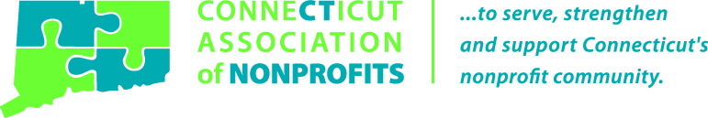

Connecticut Association of Nonprofits - We help nonprofits help Connecticut.

Connecticut Association of Nonprofits (CT Nonprofits) is the largest membership organization in the state dedicated exclusively to working with nonprofits in Connecticut. By connecting organizations with information, education, advocacy and collaboration, we help members focus their energy on the people and communities they serve.

CT Nonprofits can provide your organization with vital cost-saving opportunities, a dedicated public policy and advocacy team, specialized training and education programs, information on nonprofit trends and best practices, and connections with nonprofit colleagues throughout the state.

There are thousands of nonprofits in Connecticut – each trying to make a difference on their own. We bring them together so that each member can benefit from our collective strength.
Join CT Nonprofits today and help us continue our work of advocating for and strengthening nonprofits across Connecticut. Learn more at www.ctnonprofits.org or call us at 860-525-5080.

